53. section Intro

54. Section Roadmap

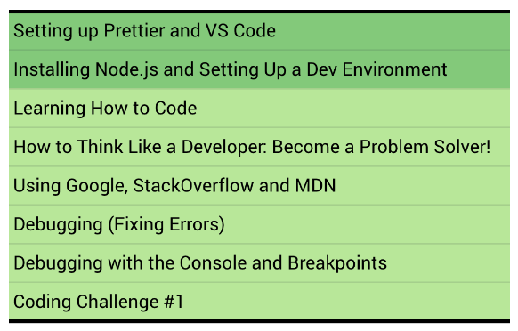

55. Setting up Prettier and VS Code

56. Installing Node.js and Setting Up a Dev Environment

57. Learning How to Code

### 



### ~~Note: Solve code war problem~~

### 

### 

58. How to Think Like a Developer: Become a Problem Solver!

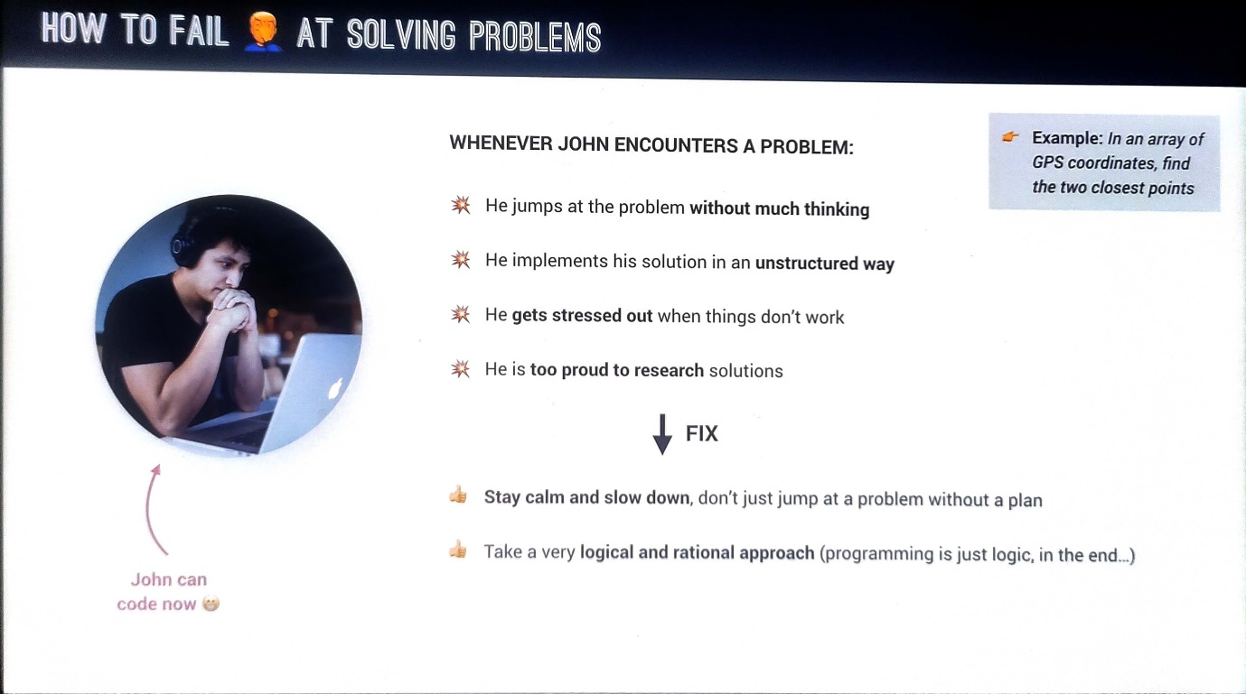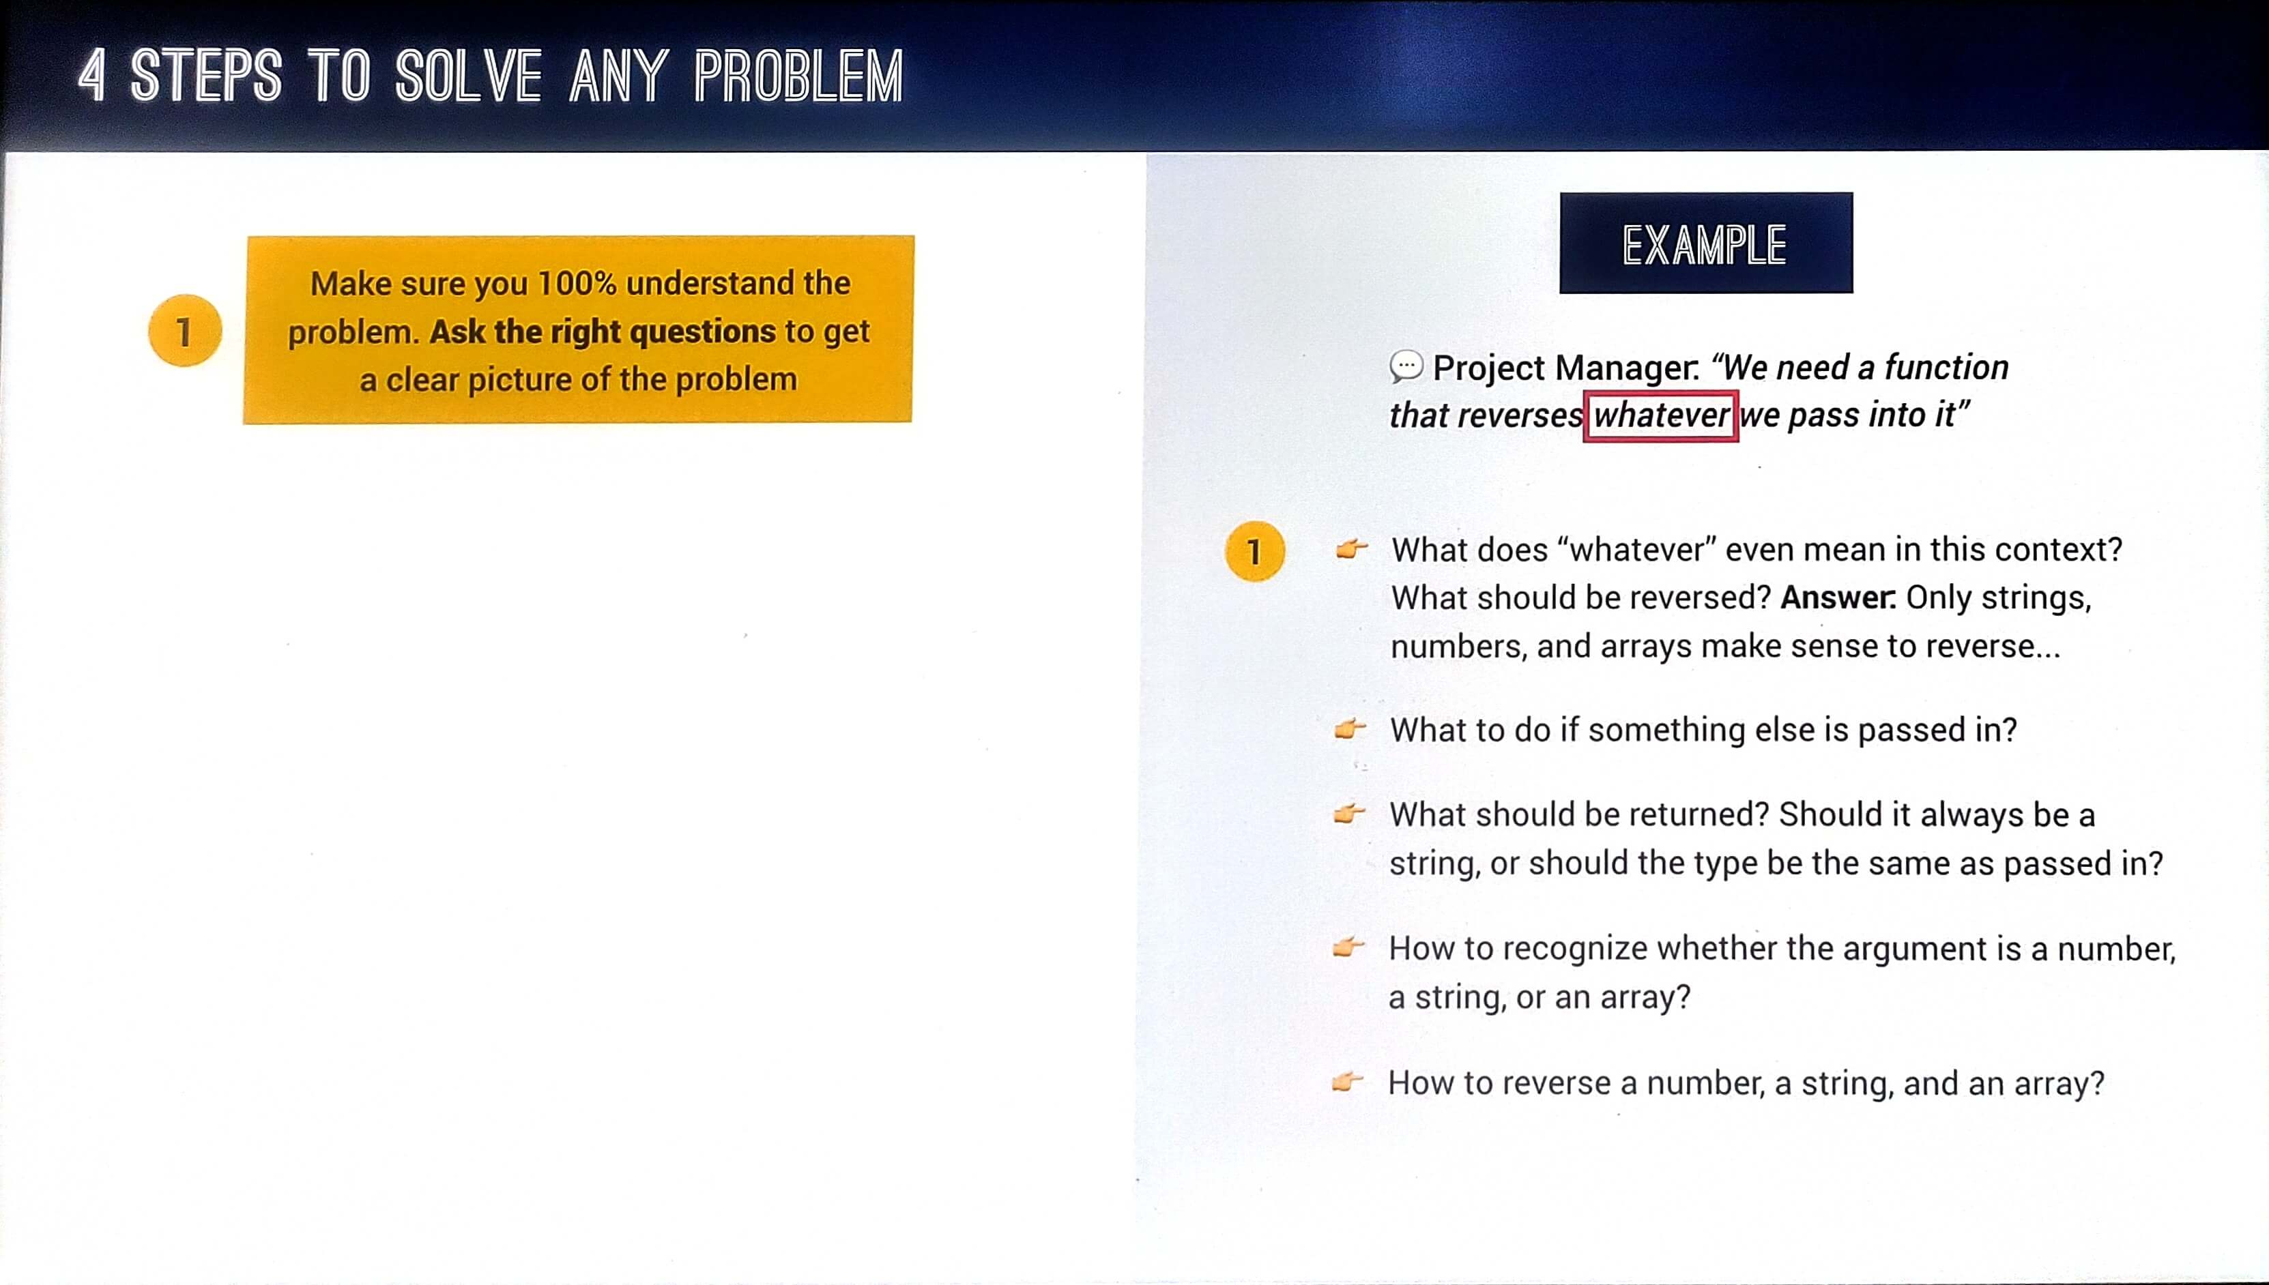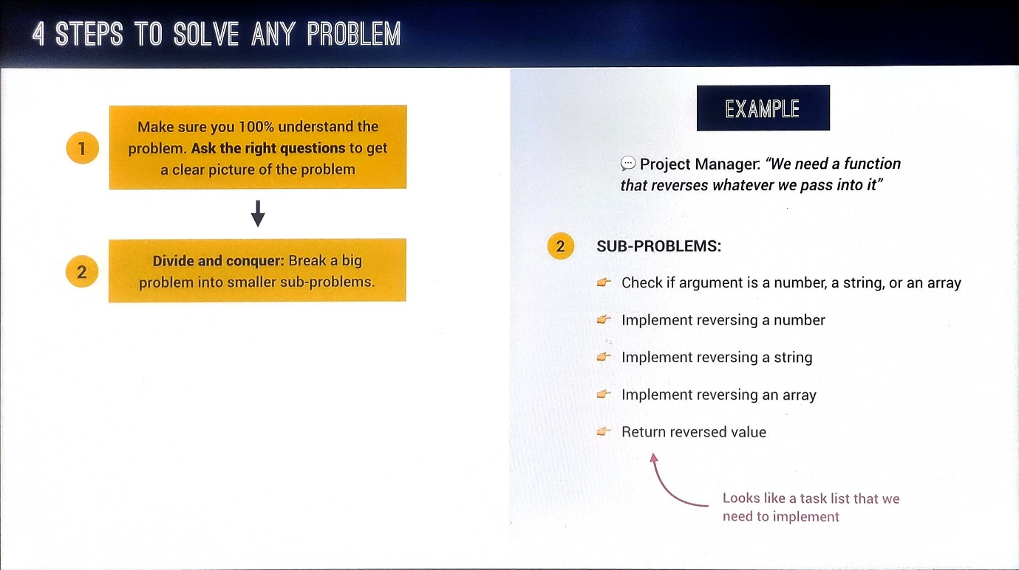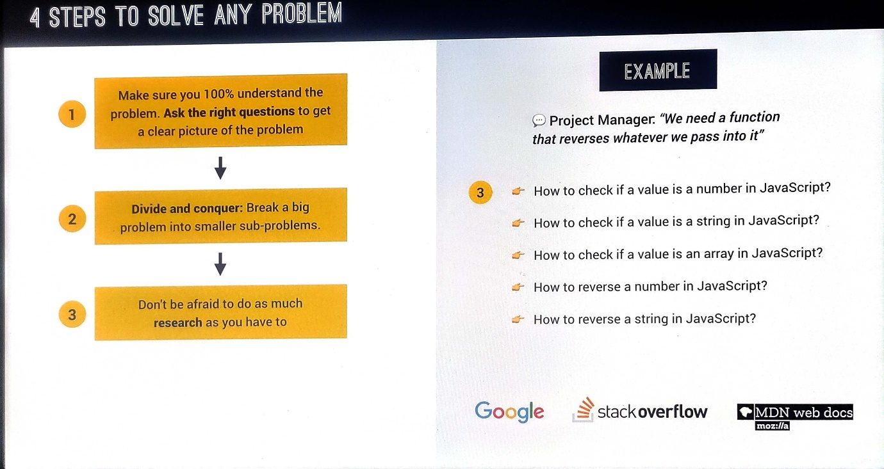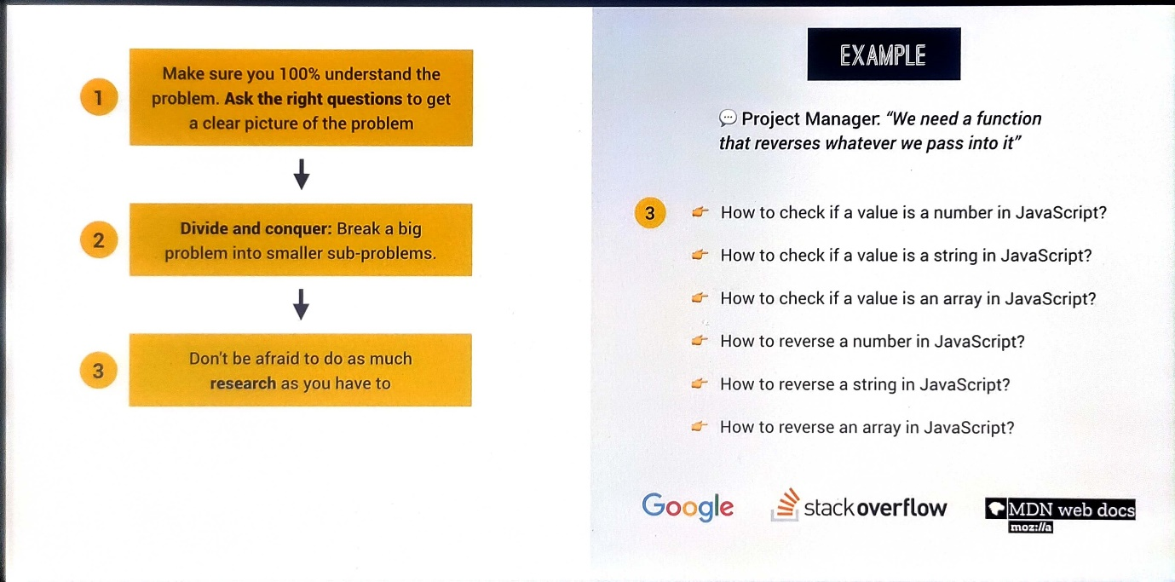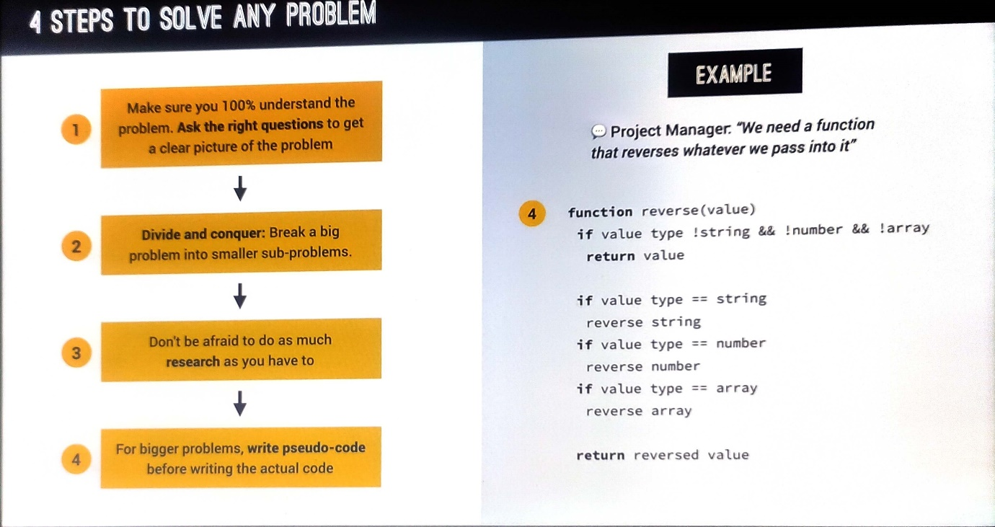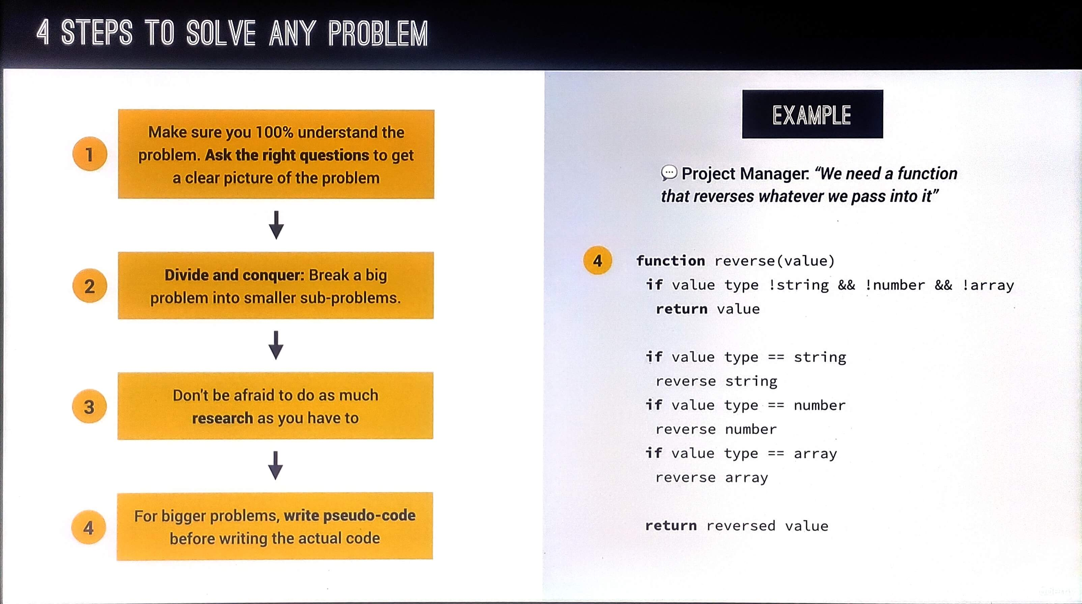

59. Using Google, Stack Overflow and MDN

60. Debugging (Fixing Errors)

61. Debugging with the Console and Breakpoints

62. Coding Challenge #1